Devon County Epée Championship
Sunday 25th January 2026

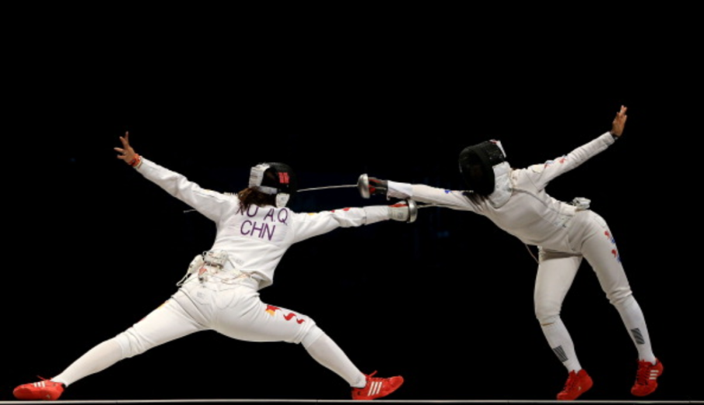
Isca Academy
Earl Richards Road
Exeter
EX2 6AP

Check-in Opens 10:15
Check-in Closes 10:45
Start fencing 11:00

Open to any fencer aged 13 or over on the day of the competition.
Devon County Champion and Master at Arms titles are reserved
to those fencers who are resident or fence in Devon.
All eligible fencers will receive South West Regional Ranking points

One seeding round of poules will be followed by full Direct Elimination tableaux.
Depending on entry for both genders, the seeding round may be combined.
Medals for each gender will be awarded to the top four overall, the best-placed Devon fencer as Devon County Champion, the best Veteran (aged over 40 on 1st January 2026), and the best Cadet (aged under 17 on 1st January 2026).
A mixed Plate competition will be included if time permits.

This is a qualifying event for the Devon County Team.
If you are selected to represent Devon, entry to this event gives free entry to the Excalibur Inter-County Competition. (Date and venue subject to confirmation).

Masters at Arms trophies for male and female fencers will be awarded for the best combined results across all three weapons of the County Championships

Current membership of British Fencing at Compete level is required for all fencers.
Fencers must use at least 800N plastrons and 350N jackets and breeches.
Tea and coffee will be available. There are no refreshment facilities at this venue.

Queries to Alex Scott: alexjmscott@hotmail.co.uk or 07899 953409

Standard entry fee £25
‘Early Bird’ discount fee £20 for entries received by 12th January

Final closing date for entries: Thursday 22nd January 2026
Entries by the ‘Early Bird’ date will be entered into a prize draw
Devon County Epée Championship Entry Form

Fencer name
BF member number Gender
Mobile or Daytime Phone
E-mail
Club Postcode

Please enter me for the Devon County Epée Championship 2026
At the standard entry fee of £25
At the ‘early bird’ discount fee of £20 (for entry by 12th January)

I have (or my parent/carer has) paid the entry fee:
By BACS to Devon County Fencing Union dated
By cheque to Devon County Fencing Union dated

Classification (please circle as appropriate)
Cadet (under 17 on 01/01/2026, i.e. born 2009 or later) YES / NO
Veteran (over 40 on 01/01/2026, i.e. born 1985 or earlier) YES / NO
Devon fencer (resident or fencing in Devon) YES / NO

The following information will help in seeding the initial poules:
When you started fencing, if less than 2 years ago
Is this your first competition? YES / NO

Entry forms should be sent to Alex Scott, 3 Shapland Place, Tiverton, EX16 5EP, or by email to alexjmscott@hotmail.co.uk. Entry fees should be paid by BACS to Devon County Fencing Union (account no. 59015454, sort code 602148, please include “Epee” in reference), or by cheque payable to Devon County Fencing Union.
All entries received will be acknowledged, normally via e-mail

Data Handling Policy By entering this competition, you agree that your competing details (name, club, BF number, gender/age classification) will be included with the published results, and your contact details may be used to send you essential information directly related to this competition (e.g. to confirm your entry or notify you of changes to arrangements).
We would like to use your contact details to invite you to other epée competitions run or supported by Devon County Fencing Union.
If you wish to take advantage of these invitations, please tick here to opt in.

Final closing date for entries: Thursday 22nd January 2026
Entries by the ‘Early Bird’ date will be entered into a prize draw

